1. Dataset Description

Loan Prediction Dataset

A loan prediction dataset is essentially a set of information about individuals applying for loans, containing details like their income, credit history, and other financial factors. This dataset serves as the foundation for training computer models to predict whether a person's loan application should be approved or not. It's akin to instructing a computer to analyze an applicant's information and decide if they are a good fit for a loan. This application is particularly valuable for financial institutions as it helps them automate and improve their decision-making processes, ensuring more informed and consistent loan approval or rejection outcomes based on historical data patterns.

These datasets play a crucial role in creating predictive models that enhance the efficiency of financial institutions' lending operations. By using past information about loan applicants, these models enable banks and companies to make quicker and more accurate decisions about loan approvals, contributing to better risk management and a streamlined lending process.

Top of Form

1. Screenshot of the Dataset Sample

With over 615 applicants details.

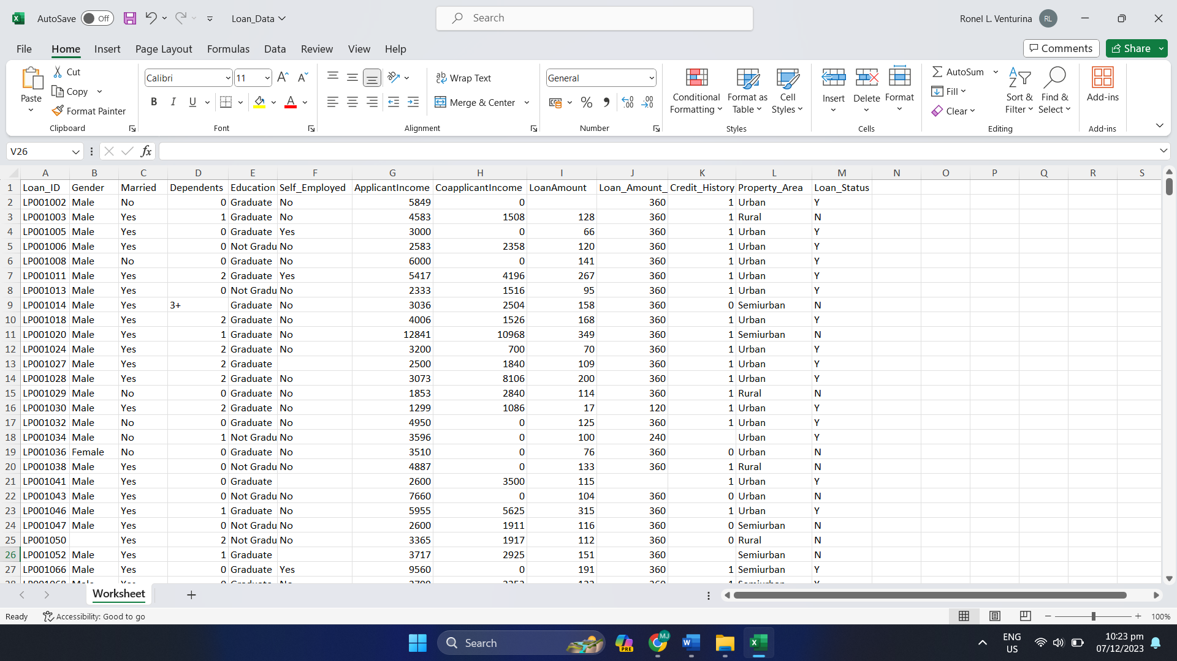

1. Description of the Algorithm Used for classification/prediction

4. Classification/Prediction Model screenshot (using Weka or any data mining tool)

5. Interpretation of the output